**Terminal Inputs and outputs  
1)**

# Import required libraries

import pandas as pd

import matplotlib.pyplot as plt

import seaborn as sns

# File paths

restaurants_path = '/Users/mohama56/BANA 5440 Python/Project 2/restaurants.csv'

reviews_path = '/Users/mohama56/BANA 5440 Python/Project 2/reviews.csv'

# Load datasets

restaurants = pd.read_csv(restaurants_path)

reviews = pd.read_csv(reviews_path)

# Get all Subway business IDs

subway = restaurants[restaurants['name'].str.contains('Subway', case=False, na=False)]

subway_ids = subway['business_id'].tolist()

# Filter reviews for Subway

subway_reviews = reviews[reviews['business_id'].isin(subway_ids)]

subway_mean = subway_reviews['stars'].mean()

subway_std = subway_reviews['stars'].std()

# Print Subway stats

print(f"Total Subway Reviews: {len(subway_reviews)}")

print(f"Updated Subway Mean Rating: {subway_mean:.2f}")

print(f"Updated Subway Standard Deviation: {subway_std:.2f}")

# Find competitors based on categories containing "Sandwiches"

competitors = restaurants[restaurants['categories'].str.contains('Sandwiches', case=False, na=False)]

competitor_ids = competitors['business_id'].iloc[:2].tolist()

# Filter reviews for competitors

competitor_reviews = reviews[reviews['business_id'].isin(competitor_ids)]

competitor_stats = competitor_reviews.groupby('business_id')['stars'].agg(['mean', 'std']).reset_index()

competitor_stats = pd.merge(competitor_stats, restaurants[['business_id', 'name']], on='business_id')

# Print competitor stats

print("\nCompetitor Ratings:")

print(competitor_stats)

# Prepare data for visualization

x_labels = ['Subway'] + competitor_stats['name'].tolist()

mean_values = [subway_mean] + competitor_stats['mean'].tolist()

std_values = [subway_std] + competitor_stats['std'].tolist()

# Visualize comparison

plt.figure(figsize=(10, 6))

sns.barplot(x=x_labels, y=mean_values, capsize=0.1)

# Add error bars manually

for idx, (mean, std) in enumerate(zip(mean_values, std_values)):

plt.errorbar(x=idx, y=mean, yerr=std, fmt='o', color='black', capsize=5)

plt.title('Mean Ratings: Subway vs Competitors')

plt.xlabel('Business')

plt.ylabel('Mean Rating')

plt.ylim(0, 5)

plt.xticks(rotation=15)

plt.grid(axis='y', linestyle='--', alpha=0.7)

plt.show()

**Output**

**2)**

# Import required libraries

import pandas as pd

import matplotlib.pyplot as plt

# File paths

restaurants_path = '/Users/mohama56/BANA 5440 Python/Project 2/restaurants.csv'

reviews_path = '/Users/mohama56/BANA 5440 Python/Project 2/reviews.csv'

# Load datasets

restaurants = pd.read_csv(restaurants_path)

reviews = pd.read_csv(reviews_path)

# Analyze ratings for sandwich restaurants

sandwich_restaurants = restaurants[restaurants['categories'].str.contains('Sandwiches', case=False, na=False)]

sandwich_ids = sandwich_restaurants['business_id'].tolist()

sandwich_reviews = reviews[reviews['business_id'].isin(sandwich_ids)]

# Calculate average and standard deviation of ratings for sandwich restaurants

sandwich_mean = sandwich_reviews['stars'].mean()

sandwich_std = sandwich_reviews['stars'].std()

print(f"Sandwich Restaurants - Mean Rating: {sandwich_mean:.2f}, Standard Deviation: {sandwich_std:.2f}")

# Analyze ratings for non-sandwich restaurants

non_sandwich_restaurants = restaurants[~restaurants['categories'].str.contains('Sandwiches', case=False, na=False)]

non_sandwich_ids = non_sandwich_restaurants['business_id'].tolist()

non_sandwich_reviews = reviews[reviews['business_id'].isin(non_sandwich_ids)]

# Calculate average and standard deviation of ratings for non-sandwich restaurants

non_sandwich_mean = non_sandwich_reviews['stars'].mean()

non_sandwich_std = non_sandwich_reviews['stars'].std()

print(f"Non-Sandwich Restaurants - Mean Rating: {non_sandwich_mean:.2f}, Standard Deviation: {non_sandwich_std:.2f}")

# Visualize comparison

categories = ['Sandwich Restaurants', 'Non-Sandwich Restaurants']

means = [sandwich_mean, non_sandwich_mean]

stds = [sandwich_std, non_sandwich_std]

plt.figure(figsize=(8, 6))

plt.bar(categories, means, yerr=stds, capsize=10, color=['orange', 'blue'])

plt.title('Comparison of Ratings: Sandwich vs Non-Sandwich Restaurants')

plt.ylabel('Mean Rating')

plt.ylim(0, 5)

plt.grid(axis='y', linestyle='--', alpha=0.7)

plt.show()

**Output**

**3)**

# Import required libraries

import pandas as pd

import matplotlib.pyplot as plt

# File paths

restaurants_path = '/Users/mohama56/BANA 5440 Python/Project 2/restaurants.csv'

reviews_path = '/Users/mohama56/BANA 5440 Python/Project 2/reviews.csv'

# Load datasets

restaurants = pd.read_csv(restaurants_path)

reviews = pd.read_csv(reviews_path)

# Count the number of unique cities for each business

city_counts = restaurants.groupby('business_id')['city'].nunique().reset_index()

city_counts.columns = ['business_id', 'city_count']

# Merge city counts back with the restaurants dataset

restaurants = pd.merge(restaurants, city_counts, on='business_id')

# Categorize restaurants as 'National' if present in >50 cities, 'Local' if present in 1 city

restaurants['chain_type'] = restaurants['city_count'].apply(

lambda x: 'National' if x > 1 else 'Local'

)

# Filter reviews for national and local chains

national_ids = restaurants[restaurants['chain_type'] == 'National']['business_id']

local_ids = restaurants[restaurants['chain_type'] == 'Local']['business_id']

national_reviews = reviews[reviews['business_id'].isin(national_ids)]

local_reviews = reviews[reviews['business_id'].isin(local_ids)]

# Calculate mean and standard deviation for ratings

national_mean = national_reviews['stars'].mean()

national_std = national_reviews['stars'].std()

local_mean = local_reviews['stars'].mean()

local_std = local_reviews['stars'].std()

# Print results

print(f"National Chains - Average Rating: {national_mean:.2f}, Standard Deviation: {national_std:.2f}")

print(f"Local Chains - Average Rating: {local_mean:.2f}, Standard Deviation: {local_std:.2f}")

# Check city count distribution

city_count_distribution = restaurants['city_count'].value_counts()

print("City Count Distribution:")

print(city_count_distribution)

# Count national and local chains

national_count = len(restaurants[restaurants['chain_type'] == 'National'])

local_count = len(restaurants[restaurants['chain_type'] == 'Local'])

print(f"\nNumber of National Chains: {national_count}")

print(f"Number of Local Chains: {local_count}")

# Check reviews for National Chains

print("\nSample Reviews for National Chains:")

print(national_reviews.head())

# Check if National Chains exist in the reviews dataset

print(f"\nNumber of reviews for National Chains: {len(national_reviews)}")

print(f"Number of reviews for Local Chains: {len(local_reviews)}")

# Visualize comparison

categories = ['National Chains', 'Local Chains']

means = [national_mean, local_mean]

stds = [national_std, local_std]

plt.figure(figsize=(8, 6))

plt.bar(categories, means, yerr=stds, capsize=10, color=['blue', 'orange'], alpha=0.7)

plt.title('Average Ratings: National vs Local Chains')

plt.ylabel('Average Rating')

plt.ylim(0, 5)

plt.grid(axis='y', linestyle='--', alpha=0.7)

plt.show()

**Output**

**4)**

**Part A**

# Import required libraries

import pandas as pd

import matplotlib.pyplot as plt

# File paths

reviews_path = '/Users/mohama56/BANA 5440 Python/Project 2/reviews.csv'

# Load dataset

reviews = pd.read_csv(reviews_path)

# Convert 'date' column to datetime format

reviews['date'] = pd.to_datetime(reviews['date'], errors='coerce') # Handle potential parsing errors

# Drop rows with invalid dates

reviews = reviews.dropna(subset=['date'])

# Extract the year from the 'date' column

reviews['year'] = reviews['date'].dt.year

# Part A: Distribution of ratings

ratings_distribution = reviews['stars'].value_counts().sort_index()

print("Overall Ratings Distribution:")

print(ratings_distribution)

# Plot overall distribution of ratings

plt.figure(figsize=(8, 6))

ratings_distribution.plot(kind='bar', color='skyblue')

plt.title('Overall Ratings Distribution')

plt.xlabel('Ratings')

plt.ylabel('Number of Reviews')

plt.grid(axis='y', linestyle='--', alpha=0.7)

plt.show()

**Output**

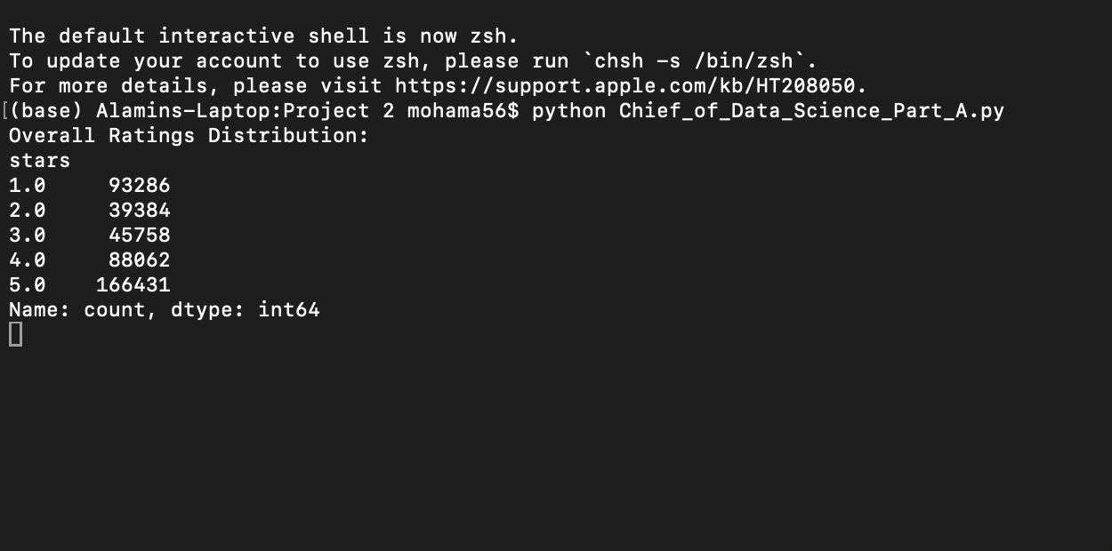

**Part B**

# Import required libraries

import pandas as pd

import matplotlib.pyplot as plt

# File path

reviews_path = '/Users/mohama56/BANA 5440 Python/Project 2/reviews.csv'

# Load dataset

reviews = pd.read_csv(reviews_path)

# Convert 'date' column to datetime format and handle errors

reviews['date'] = pd.to_datetime(reviews['date'], errors='coerce')

# Drop rows with invalid dates

reviews = reviews.dropna(subset=['date'])

# Extract the year from the 'date' column

reviews['year'] = reviews['date'].dt.year

# Filter data for the years 2018 to 2021

years_to_analyze = [2018, 2019, 2020, 2021]

filtered_reviews = reviews[reviews['year'].isin(years_to_analyze)]

# Debugging: Check filtered data

print("\nFiltered Reviews (First 5 Rows):")

print(filtered_reviews[['year', 'stars']].head())

# Group by year and rating to calculate the distribution

yearly_distributions = filtered_reviews.groupby(['year', 'stars']).size().unstack(fill_value=0)

# Debugging: Ensure yearly distribution table is correct

if yearly_distributions.empty:

print("\nNo data available for the specified years (2018–2021).")

else:

print("\nYearly Ratings Distribution (2018–2021):")

print(yearly_distributions)

# Plot yearly distribution of ratings

yearly_distributions.plot(kind='bar', figsize=(12, 8), stacked=True, colormap='viridis', width=0.8)

plt.title('Yearly Ratings Distribution (2018–2021)')

plt.xlabel('Year')

plt.ylabel('Number of Reviews')

plt.legend(title='Ratings', loc='upper left', bbox_to_anchor=(1.0, 1.0))

plt.grid(axis='y', linestyle='--', alpha=0.7)

plt.tight_layout()

plt.show()

**Output**

**Bonus Question-3**

**Visuals**

# Import required libraries

import pandas as pd

import matplotlib.pyplot as plt

# File paths

reviews_path = '/Users/mohama56/BANA 5440 Python/Project 2/reviews.csv'

restaurants_path = '/Users/mohama56/BANA 5440 Python/Project 2/restaurants.csv'

# Load datasets

reviews = pd.read_csv(reviews_path)

restaurants = pd.read_csv(restaurants_path)

# Convert 'date' column to datetime format

reviews['date'] = pd.to_datetime(reviews['date'])

# Extract the year and month from the 'date' column

reviews['year'] = reviews['date'].dt.year

reviews['month'] = reviews['date'].dt.month

# Visual 1: Yearly Ratings Distribution

print("\nGenerating Visual 1: Yearly Ratings Distribution...")

yearly_distribution = reviews.groupby(['year', 'stars']).size().unstack(fill_value=0)

print("\nYearly Ratings Distribution (2018–2021):")

print(yearly_distribution.loc[2018:2021]) # Only print years 2018–2021

# Plot yearly distribution of ratings

yearly_distribution.plot(kind='bar', figsize=(12, 8), stacked=True, colormap='viridis', width=0.8)

plt.title('Yearly Ratings Distribution (2018–2021)')

plt.xlabel('Year')

plt.ylabel('Number of Reviews')

plt.legend(title='Ratings', loc='upper left', bbox_to_anchor=(1.0, 1.0))

plt.grid(axis='y', linestyle='--', alpha=0.7)

plt.tight_layout()

plt.show()

# Visual 2: Bottom 10 Subway Locations by Average Rating

print("\nGenerating Visual 2: Bottom 10 Subway Locations by Average Rating...")

location_ratings = reviews.groupby('business_id')['stars'].mean().reset_index()

location_ratings = pd.merge(location_ratings, restaurants[['business_id', 'name', 'city', 'state']], on='business_id', how='left')

bottom_10_locations = location_ratings.sort_values(by='stars', ascending=True).head(10)

print("\nBottom 10 Subway Locations by Average Rating:")

print(bottom_10_locations[['name', 'city', 'state', 'stars']])

# Plot bottom 10 Subway locations by average rating

bottom_10_locations.plot(

x='name', y='stars', kind='barh', figsize=(10, 6), color='orange'

)

plt.title('Bottom 10 Subway Locations by Average Rating')

plt.xlabel('Average Rating')

plt.ylabel('Subway Location')

plt.grid(axis='x', linestyle='--', alpha=0.7)

plt.tight_layout()

plt.show()

# Visual 3: Monthly Trend of Average Ratings

print("\nGenerating Visual 3: Monthly Trend of Average Ratings...")

monthly_ratings = reviews.groupby('month')['stars'].mean().reset_index()

print("\nMonthly Average Ratings:")

print(monthly_ratings)

# Plot monthly trend of ratings

plt.figure(figsize=(10, 6))

plt.plot(

monthly_ratings['month'], monthly_ratings['stars'],

marker='o', linestyle='-', color='blue'

)

plt.title('Monthly Trend of Average Ratings')

plt.xlabel('Month')

plt.ylabel('Average Rating')

plt.xticks(range(1, 13))

plt.grid(axis='both', linestyle='--', alpha=0.7)

plt.tight_layout()

plt.show()